NUS GRIP
Ambient Systems
MVP Budget Request
Version: 01
March 4, 2021

Intro & Background

Ambient is an NUS GRIP startup with a mission to empower building operators to easily manage the indoor climate. Most solutions in this space are focused on optimizing a single goal, such as reducing energy costs. Ambient’s product consists of an end-to-end hardware stack, dashboard, and optimization model leverage latest innovations in machine learning to manage multiple critical yet competing priorities. In particular, the goal of the MVP is to demonstrate the optimization capabilities that a customer can see in their building.

Scope
We are seeking a budget to develop a portion of the software as part of the MVP. The goal is to use the MVP to gain further traction with customers and demonstrate the technology to the GRIP investment panel in May. The initial product will be focused on the indoor farming segment based on the UI designs in [Team member]

The initial feature list based on the UI designs:
- Display data in different chart formats (bar graph, scatter plot, radar chart, pie chart) (4-6 objects)
- Map interface (indoor map of the floor plan with various equipment)
- Filter (and sort) data by time (and other attributes)
- Export data in json format
- Basic user inputs (user can input and toggle preferred settings) (4-6 input settings)

Deliverables

A single-page web dashboard to display real-time data information and provide way for user to input their preferences into the system.

Schedule with Milestones

- Mar 10: tentative start
- Mar 17: v01 complete
  - Feature 1
  - Feature 3
- Apr 1: v02 complete
  - Feature 2
  - Feature 5
- May 14: v03 (final complete)
  - Feature 4

Cost

The estimated cost is based on the amount of hours that the developer will need to implement the MVP. The fidelity of the dashboard will impact the cost. The current cost estimate is between $3,000 and $6,000.

Appendix A: UI Design
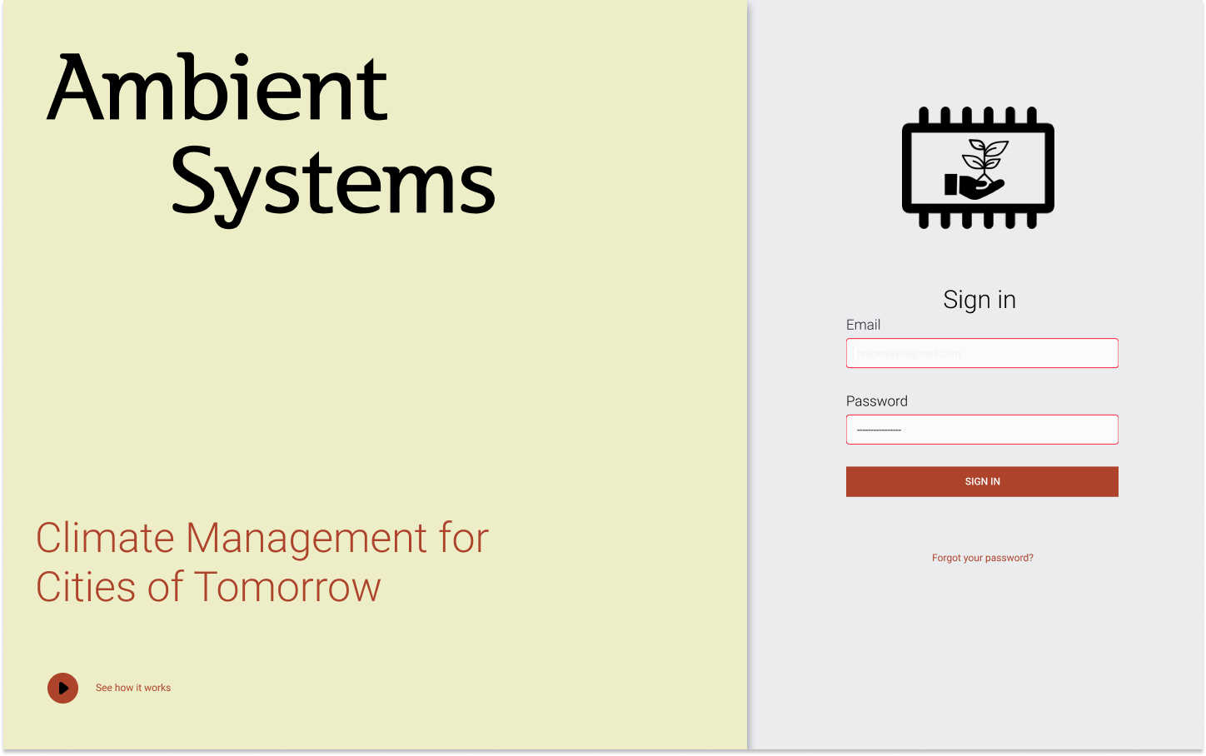
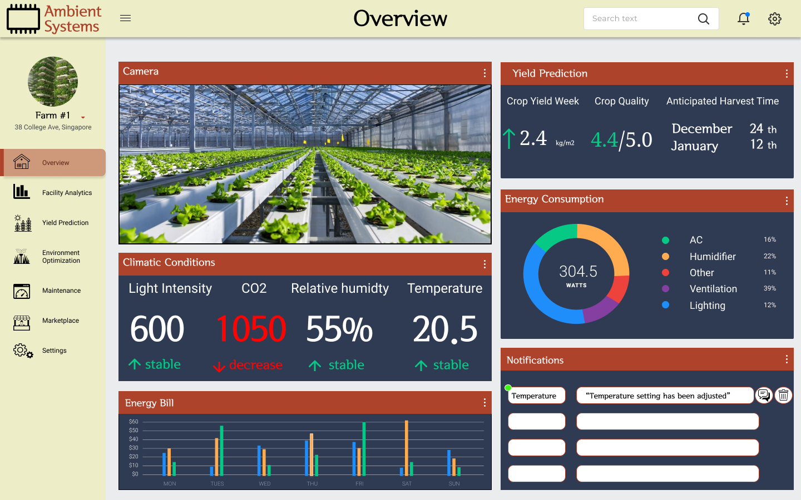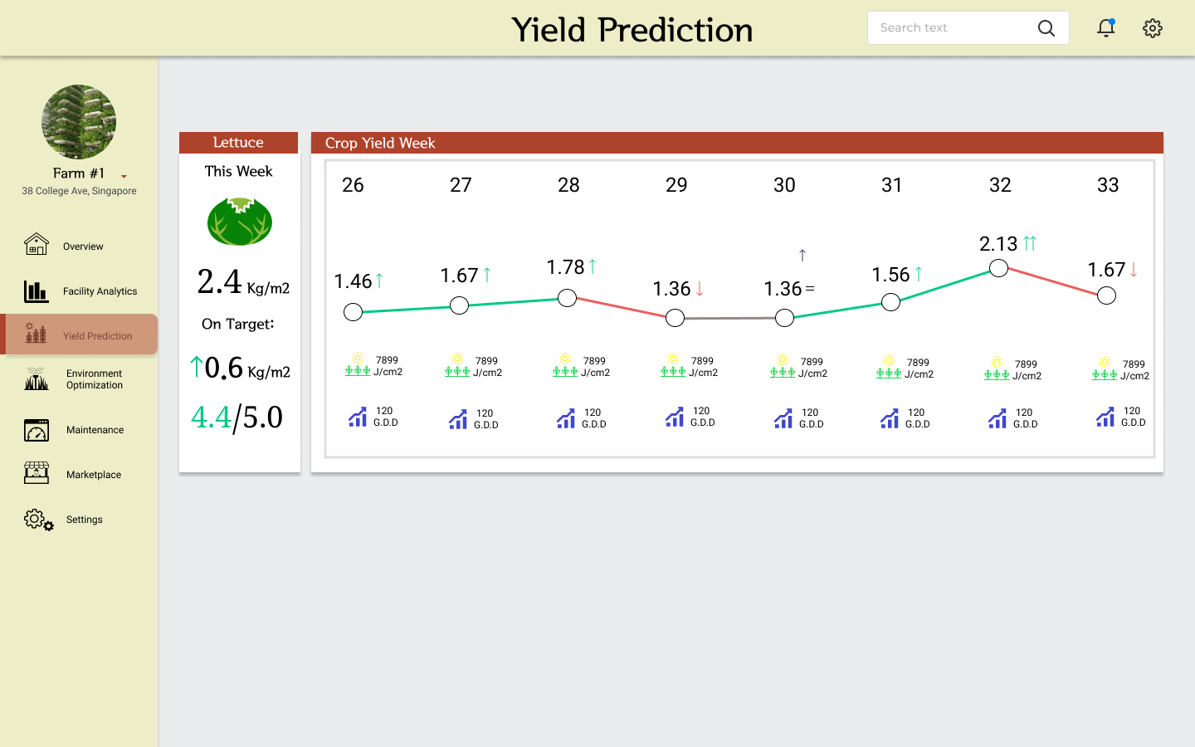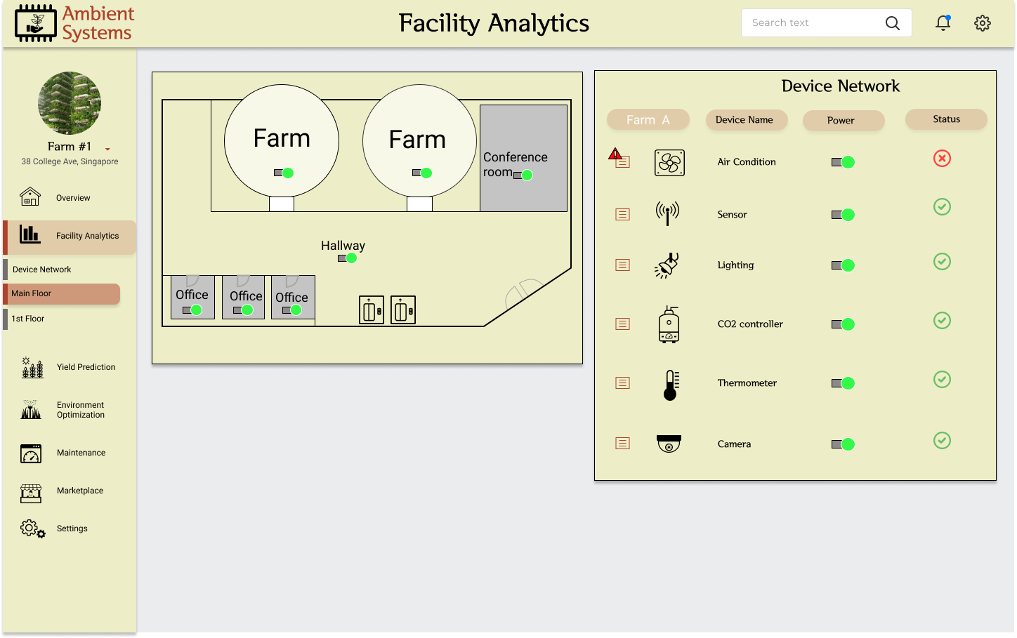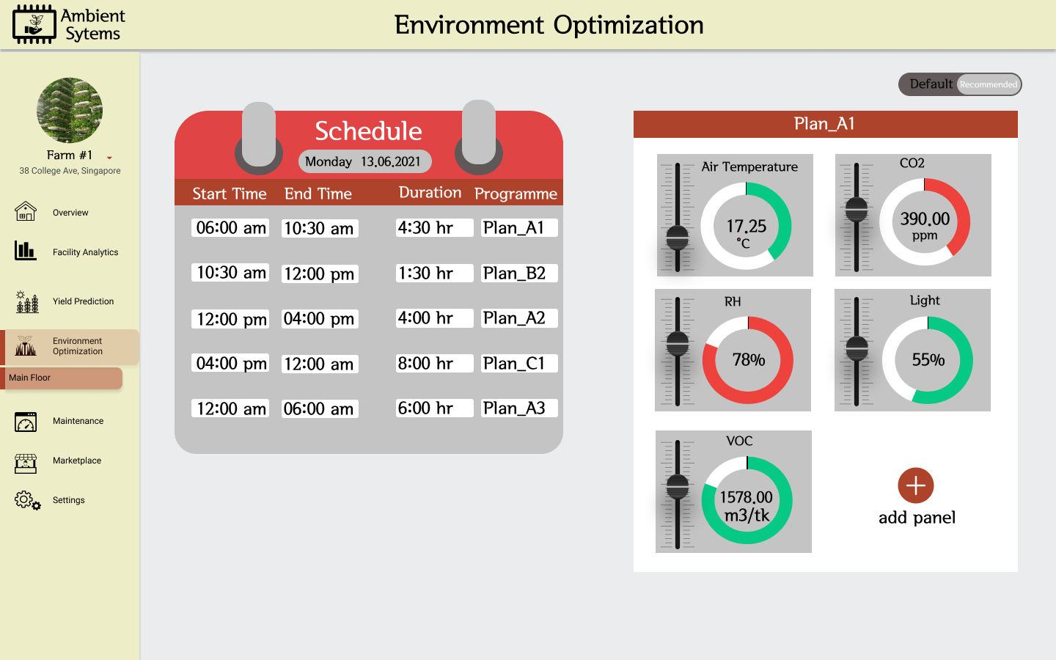
Appendix B: Quotes
